**Test Automation Project Work**

**Test Cases for Automation:**

* **Test Case 1: Sign up for Yahoo Finance - negative**

1. Go to <https://finance.yahoo.com/>
2. Click on ‘Sign In’ button
3. Click on ‘Create an account’ button
4. Populate invalid data for all of the fields and press Continue (Prepare 2 sets of negative test data)
5. Verify all errors messages for each field (as it is shown on the photo)

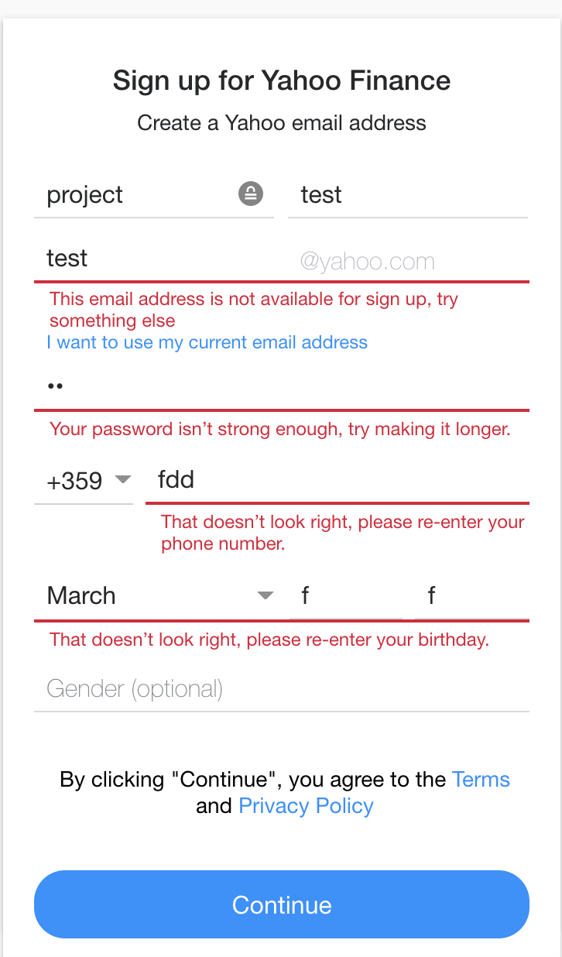

* **Test Case 2: Check historical data for a company stock**

1. Go to <https://finance.yahoo.com/>
2. In the search field, type a name of a company e.g. Apple (The names of the companies had to be provided by external file)
3. Select the typed company -> The Summary tab for the company is opened
4. Verify the company Dividends rate - if the field “**Forward Dividend & Yield**” contains N/A then the company is not giving Dividends. For the test you have to use 2 companies (Apple and Amazon). The data for the dividend rate has to be provided in the external file together with the name of the company. Example:

**Amazon, N/A (N/A)**

**Apple, 0.82 (0.76%)**

1. Open “Historical Data” tab
2. Apply a filter (Time Period – 5D, Frequency – Daily)

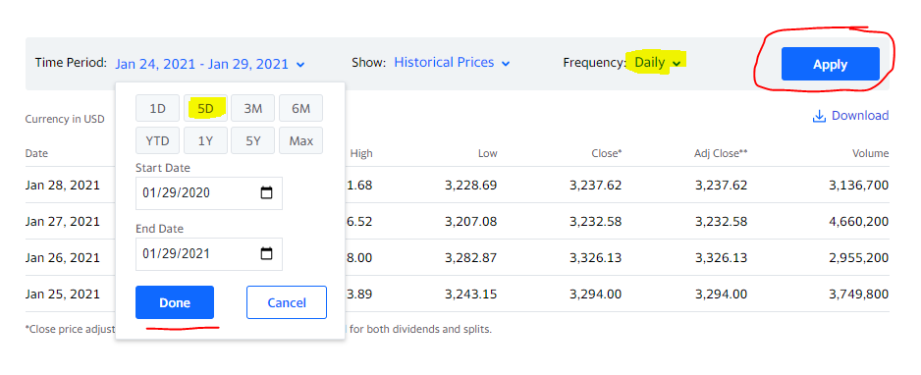

1. Get the **High** and **Low** values for the **Yesterday** date. Identify which row data to be collected using a Xpath that includes the date in it.
2. Verify the **High** amount is bigger than the **Low** value.

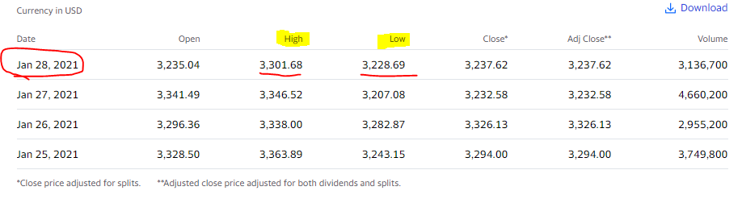

**Requirements for the project:**

1. Page Object Model (POM) is used for designing the classes
2. The project must support as least 2 browsers (Firefox and Chrome)
3. The selected browser and the URL are provided by configuration file
4. Driver is quit after the execution of each test
5. Each test case should be part of different test group
6. Prepare 3 xml test suites (first one with one group included, second with a group excluded and the last one must execute all the tests.
7. The tests are executed in parallel.
8. The test data is stored in external files (csv, excel, configs or else)
9. Data driven approach is used and the data is provided by Data Provider to the tests.
10. You must demonstrate at least 2 types of Wait principles in the project.